
Name: _______________________
My Target: /45 or ____%  

UNIT 2 ATAR GEOGRAPHY – Weighting 7%
Task 12 – In-class Assessment - Depth Study 2 – Tourism

TOTAL = ____________________/ 45 Marks

Time Allocation: 5 minutes reading time and 50 minutes working time
Section One – Multiple Choice (10 marks)

- What is a tourist?
- A person who travels just for business
- Someone who visits a place far away from their home for more than a month
- Someone who travels away from their home for pleasure
- Someone who travels outside of their normal place or work or residence for recreational or business purposes

- Which of the following is a reason for increasing numbers of tourists?
- Fewer paid holidays
- COVID-19 Pandemic
- Cheaper flights
- People working longer hours

- In recent years where has tourism grown most rapidly?
- Asia
- North America
- Outer Space
- Europe

- Which of the following is a benefit of tourism?
- Changing culture and traditions
- Tourist money used to look after historic buildings
- Habitats destroyed
- Increased crime rates

- Which of the following is a negative impact of tourism?
- New jobs are created
- Local goods become too expensive for local people
- Social policies are created to encourage tourism
- New facilities are built

- Why can it be a problem if a country relies heavily on tourism?
- Because tourists are badly behaved
- Because tourists bring lots of money in with them
- Because tourists generate demand and contribute positively to GDP
- Because tourists might stop coming and the country will have no other source of income

- How might the natural environment be damaged by tourism?
- Footpath erosion
- Disturbed feeding and breeding habits
- Litter
- Both footpath erosion and litter

- Which of the following is not a reason for the growth of the tourism industry?
- Greater affluence
- Less leisure time
- Improved accessibility and transport facilities
- Innovations in transportation technologies

- Tourism is classified as which of the following:
- Commodity
- Good
- Service
- Good and Service

- Which of the following is an example of an enterprise involved in the internationalisation of Tourism in Western Australia?
- Tourism Australia
- Tourism WA
- Crown Resorts
- Venues West

Section Two – Short Answer

- With examples, describe the nature of Tourism. (6 marks)

____________________________________________________________________________________________________________________________________________________________________________________________________________________________________________________________________________________________________________________________________________________________________________________________________________________________________________________________________________________________________________________________________________________________________________________________________________________________________________________________________________________________________________________________________________________________________________________________________________________________________________________________________________________________________________________________________________________________________________________________________________________________________________________________________________________________________________________________________
________________________________________________________________________________________________________________________________________________________________________________________________________________________________________________________________________________________________________________________________________________________________________________________________________________________________________________________________________________________________________________________________________________________________________________________________________________________________________________
- State and describe one positive social implication of Tourism and one negative social implication of Tourism. (6 marks)

- ________________________________________________________________________
____________________________________________________________________________________________________________________________________________________________________________________________________________________________________________________________________________________________________________________________________________________________________________________________________________________________________________________________________________________________________________________________________________________________________________________________________________________________________________________________________________________________________________________________________________________________________________________________________________________________________________________________________________________________________________________________________________________________________________________________________________________________________________________________________________________________________________________________________

- ________________________________________________________________________
____________________________________________________________________________________________________________________________________________________________________________________________________________________________________________________________________________________________________________________________________________________________________________________________________________________________________________________________________________________________________________________________________________________________________________________________________________________________________________________________________________________________________________________________________________________________________________________________________________________________________________________________________________________________________________________________________________________________________________________________________________________________________________________________________________________________________________________________________

- State and describe one positive environmental implication of Tourism and one negative environmental implication of Tourism. (6 marks)

- ________________________________________________________________________
____________________________________________________________________________________________________________________________________________________________________________________________________________________________________________________________________________________________________________________________________________________________________________________________________________________________________________________________________________________________________________________________________________________________________________________________________________________________________________________________________________________________________________________________________________________________________________________________________________________________________________________________________________________________________________________________________________________________________________________________________________________________________________________________________________________________________________________________________

- ________________________________________________________________________
____________________________________________________________________________________________________________________________________________________________________________________________________________________________________________________________________________________________________________________________________________________________________________________________________________________________________________________________________________________________________________________________________________________________________________________________________________________________________________________________________________________________________________________________________________________________________________________________________________________________________________________________________________________________________________________________________________________________________________________________________________________________________________________________________________________________________________________________________

Refer to Source 1 to complete question 4.

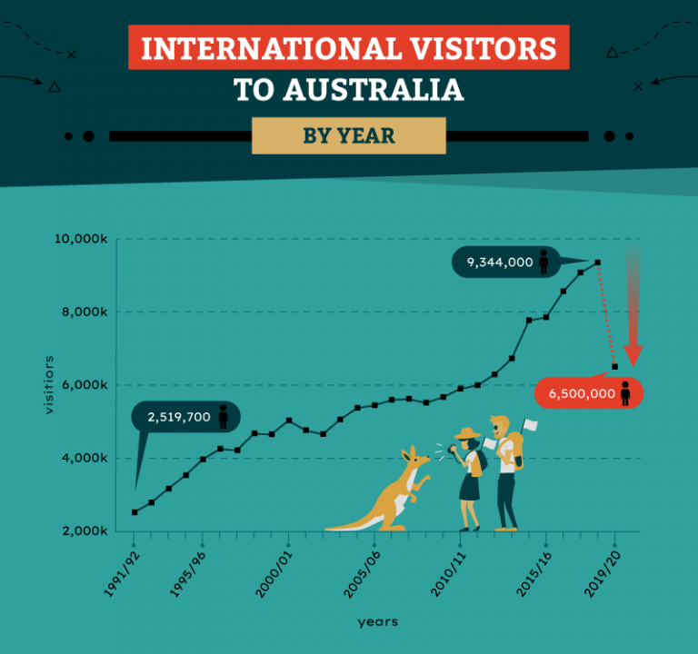
Source 1: International Visitors to Australia: By Year. Source ABS Statistics.

- With reference to Source 1, describe and account for the trend in the number of international visitors coming to Australia. (5 marks)

______________________________________________________________________________________________________________________________________________________________________________________________________________________________________________________________________________________________________________________________________________________________________________________________________________________________________________________________________________________________________________________________________________________________________________________________________________________________________________________________________________________________________________________________
______________________________________________________________________________________________________________________________________________________________________________________________________________________________________________________________________________________________________________________________________________________________________________________________________
____________________________________________________________________________________________________________________________________________________________________________________________________________________________________________________________________________________________________________________________________________________________________________________________________________________________________________________________________________________________________________________________________________________________________________________________________________________________________________________________________________________________________________________________________________________________________________________________________________________________________________________________________________________________________________________________________________________________________________________________________________________________________________________________________________________________________________________________________

Section Three– Extended Response
Choose one of the following questions to compose an extended response to.

- Evaluate the role and impact of technological advances in transport and/or telecommunications in changing the spatial distribution of a commodity, good or service you have studied. (12 marks)
OR
- Explain the role played by governments and enterprises in the internationalisation of the production and consumption of a selected commodity, good or service. (12 marks)

Note: A good answer will refer to key terms from the question, including a clear and concise meaning of these terms.
________________________________________________________________________________________________________________________________________________________________________________________________________________________________________________________________________________________________________________________
________________________________________________________________________________________________________________________________________________________________________________________________________________________________________________________________________________________________________________________
________________________________________________________________________________________________________________________________________________________________________________________________________________________________________________________________________________________________________________________
________________________________________________________________________________________________________________________________________________________________________________________________________________________________________________________________________________________________________________________
________________________________________________________________________________________________________________________________________________________________________________________________________________________________________________________________________________________________________________________
________________________________________________________________________________________________________________________________________________________________________________________________________________________________________________________________________________________________________________________
________________________________________________________________________________________________________________________________________________________________________________________________________________________________________________________________________________________________________________________
________________________________________________________________________________________________________________________________________________________________________________________________________________________________________________________________________________________________________________________
________________________________________________________________________________________________________________________________________________________________________________________________________________________________________________________________________________________________________________________
________________________________________________________________________________________________________________________________________________________________________________________________________________________________________________________________________________________________________________________
________________________________________________________________________________________________________________________________________________________________________________________________________________________________________________________________________________________________________________________
________________________________________________________________________________________________________________________________________________________________________________________________________________________________________________________________________________________________________________________
________________________________________________________________________________________________________________________________________________________________________________________________________________________________________________________________________________________________________________________
________________________________________________________________________________________________________________________________________________________________________________________________________________________________________________________________________________________________________________________
________________________________________________________________________________________________________________________________________________________________________________________________________________________________________________________________________________________________________________________
________________________________________________________________________________________________________________________________________________________________________________________________________________________________________________________________________________________________________________________
________________________________________________________________________________________________________________________________________________________________________________________________________________________________________________________________________________________________________________________
________________________________________________________________________________________________________________________________________________________________________________________________________________________________________________________________________________________________________________________
________________________________________________________________________________________________________________________________________________________________________________________________________________________________________________________________________________________________________________________
________________________________________________________________________________________________________________________________________________________________________________________________________________________________________________________________________________________________________________________
________________________________________________________________________________________________________________________________________________________________________________________________________________________________________________________________________________________________________________________
________________________________________________________________________________________________________________________________________________________________________________________________________________________________________________________________________________________________________________________________________________________________________________________________________________________________________________________________________________________________________________________________________________________________________________________________________________________________________________
________________________________________________________________________________________________________________________________________________________________________________________________________________________________________________________________________________________________________________________
________________________________________________________________________________________________________________________________________________________________________________________________________________________________________________________________________________________________________________________
________________________________________________________________________________________________________________________________________________________________________________________________________________________________________________________________________________________________________________________

End of Assessment

Extra Page: ________________________________________________________________________________________________________________________________________________________________________________________________________________________________________________________________________________________________________________________
________________________________________________________________________________________________________________________________________________________________________________________________________________________________________________________________________________________________________________________
________________________________________________________________________________________________________________________________________________________________________________________________________________________________________________________________________________________________________________________
________________________________________________________________________________________________________________________________________________________________________________________________________________________________________________________________________________________________________________________
________________________________________________________________________________________________________________________________________________________________________________________________________________________________________________________________________________________________________________________________________________________________________________________________________________________________________________________________________________________________________________________________________________________________________________________________________________________________________________
________________________________________________________________________________________________________________________________________________________________________________________________________________________________________________________________________________________________________________________
________________________________________________________________________________________________________________________________________________________________________________________________________________________________________________________________________________________________________________________
________________________________________________________________________________________________________________________________________________________________________________________________________________________________________________________________________________________________________________________

